

Data Structures And Algorithms
( Course Code: CSC211 )

Name : Syeda Aima Abbas
Roll No # FA24-BSE-010
Instructor Name : Sir Atique

Assignment # 2
Lab Part

Q#1: E-Commerce Return Management System (Static Stack Implementation)
Major online retailers such as Daraz and Amazon process hundreds of product return requests every hour. The Return Management Department handles these requests in reverse order of arrival to quickly resolve the most recent issues first. Design and implement a static stack (array-based) system that stores customer return requests. Each request includes: • Order ID • Customer Name • Return Reason • Date of Request Operations: 1. pushReturnRequest() – Add a new return request to the stack. 2. popReturnRequest() – Process and remove the latest request. 3. peekLatestRequest() – View the most recent request awaiting review. 4. displayAllRequests() – Display all unprocessed requests. This simulation helps analyze how LIFO operations assist in managing real-time customer service workflows.

CODE
// Major online retailers such as Daraz and Amazon process hundreds of product return requests every hour. The Return Management
// Department handles these requests in reverse order of arrival to quickly resolve the most recent issues first.
// Design and implement a static stack (array-based) system that stores customer return requests.
// Each request includes:
// • Order ID
// • Customer Name
// • Return Reason
// • Date of Request
// Operations:
// 1. pushReturnRequest() – Add a new return request to the stack.
// 2. popReturnRequest() – Process and remove the latest request.
// 3. peekLatestRequest() – View the most recent request awaiting review.
// 4. displayAllRequests() – Display all unprocessed requests.

#include <iostream>
using namespace std;

class Stack {
public:
int id[5];
string name[5];
string reason[5];
string date[5];
int top;
public:
Stack() {
top = -1;
}

void pushReturnRequest(int id,string name,string reason,string date) {
if (top == 4) {
cout << "Stack Overflow\n";
return;
}
top++;
this->id[top] = id;
this->name[top]=name;
this->reason[top]=reason;
this->date[top]=date;
cout << "Data pushed\n";
}

void popReturnRequest() {
if (top == -1) {
cout << "No requests to process.\n";
return;
}
cout << "Deleting latest request:\n";
cout << id[top] << " " << name[top] << " " << reason[top] << " " << date[top] << endl;
top--;
}

void peekLatestRequest(){
if (top == -1) {
cout << "No pending requests.\n";
return;
}
cout << "Latest request \n";
cout << id[top] << " " << name[top] << " " << reason[top] << " " << date[top] << endl;
}

void displayAllRequest() {
if (top == -1) {
cout << "No pending requests.\n";
return;
}
cout << "Submitted Requests: " << endl;
for (int i = top; i >= 0; i--){
cout << id[i] << " " ;
cout << name[i] << " " ;
cout << reason[i] << " " ;
cout << date[i] << " " ;
cout << endl;
}
}
};

int main() {
Stack s;
s.pushReturnRequest(1,"Aima","didnt like product","24-09-2024");
s.pushReturnRequest(2,"Aima","didnt like product","24-09-2024");
s.pushReturnRequest(3,"Aima","didnt like product","24-09-2024");
s.pushReturnRequest(4,"Aima","didnt like product","24-09-2024");
s.pushReturnRequest(5,"Aima","didnt like product","24-09-2024");
s.displayAllRequest();
s.popReturnRequest();
s.displayAllRequest();
s.peekLatestRequest();
}

OUTPUT
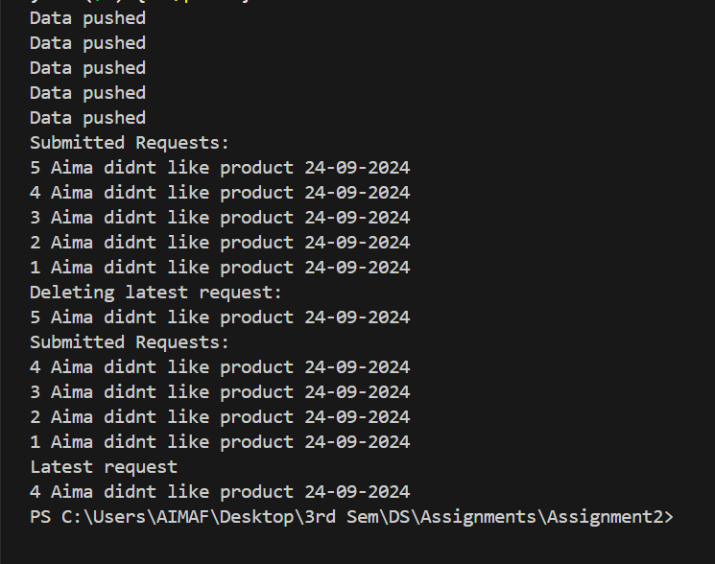

Q#2 : Browser History Navigation Manager (Dynamic Stack Implementation)
Modern browsers (e.g., Google Chrome, Mozilla Firefox) maintain a navigation history that allows users to go back and forth between visited websites. This navigation history internally functions as a stack. Implement a dynamic stack (linked-list-based) to simulate a simplified browser history system. Each node represents a webpage containing: • Page Title • URL • Time Visited Operations: 1. visitPage(url) 2. goBack() 3. viewCurrentPage() 4. displayHistory() This case study demonstrates how browsers use stack principles to manage navigation flow efficiently.

CODE:
// Modern browsers (e.g., Google Chrome, Mozilla Firefox) maintain a navigation history that allows users to go back and forth between
// visited websites. This navigation history internally functions as a stack.
// Implement a dynamic stack (linked-list-based) to simulate a simplified browser history system. Each node represents a webpage
// containing:
// • Page Title
// • URL
// • Time Visited
// Operations:
// 1. visitPage(url)
// 2. goBack()
// 3. viewCurrentPage()
// 4. displayHistory()
#include <iostream>
using namespace std;
class Node{
public:
string url;
string time;
string title;
Node* next;

Node(string url,string time,string title){
this->title=title;
this->url=url;
this->time=time;
next=nullptr;
}
};

class Stack {
public:
Node* head;
Node* curr;

Stack(){
curr=head=nullptr;
}

void visitPage(string url,string time,string title){
Node* newNode = new Node(url,time,title);
if(head==nullptr){
curr=head=newNode;
}else{
newNode->next=head;
head=newNode;
curr=newNode;
}
cout << "Visited: " << title << " (" << url << ") at " << time << endl;
}

void goBack(){
if(head==nullptr){
cout << "Empty";
return;
}
if(head->next==nullptr){
cout << "Going back from \n";
cout << head->url << " " << head->title << " " << head->time << " " << endl;
delete head;
curr=head=nullptr;
return;
}
Node* del=head;
cout << "Going back from \n";
cout << head->url << " " << head->title << " " << head->time << " " << endl;
head=head->next;
delete del;
curr=head;
}

void viewCurrentPage(){
if(curr==nullptr){
cout << "Empty";
return;
}
cout << "Current Page is: \n";
cout << curr->url << " " << curr->title << " " << curr->time << " " << endl;
}

void displayHistory(){
if(head==nullptr){
cout << "Empty";
return;
}
Node* temp=head;
cout << "History is" << endl;
while(temp!=nullptr){
cout << temp->url << " " << temp->title << " " << temp->time << " " << endl;
temp=temp->next;
}
}

};
int main() {
Stack browser;
browser.visitPage("https://www.google.com", "10:00 AM", "Google");
browser.visitPage("https://www.github.com", "10:10 AM", "GitHub");
browser.visitPage("https://www.youtube.com", "10:20 AM", "YouTube");

cout << endl;
browser.viewCurrentPage();

cout << endl;
browser.displayHistory();

cout << endl;
browser.goBack();
cout << endl;
browser.viewCurrentPage();

cout << endl;
browser.displayHistory();
return 0;
}

OUTPUT:
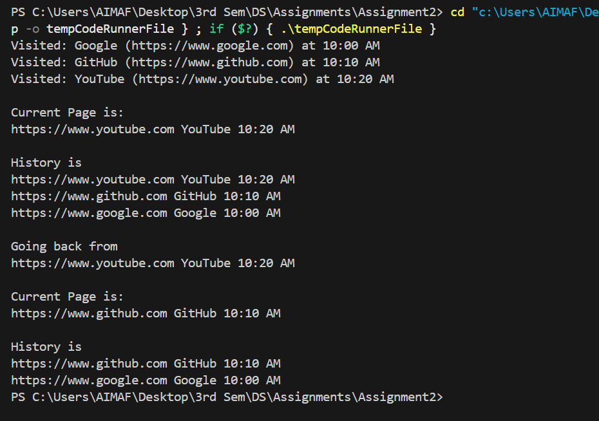

Q#3: : Expression Evaluation in a Scientific Calculator (Application of Stack)
A scientific calculator application developed for engineers must evaluate mathematical expressions entered in postfix (Reverse Polish) notation. Each expression may contain: • Single- or multi-digit operands (non-negative integers) • Arithmetic operators: +, -, *, / Design a stack-based evaluator that computes the result of such expressions. Example: Input → 23-4+567*+* | Output → 141 The evaluator should process each character sequentially, pushing operands and applying operators as they appear.

CODE:
// A scientific calculator application developed for engineers must evaluate mathematical expressions entered in postfix (Reverse Polish)
// notation. Each expression may contain:
// • Single- or multi-digit operands (non-negative integers)
// • Arithmetic operators: +, -, *, /
// Design a stack-based evaluator that computes the result of such expressions.
// Example: Input → 23-4+567*+* | Output → 141
// The evaluator should process each character sequentially, pushing operands and applying operators as they appear.
#include <iostream>
#include <stack>
using namespace std;

int main()
{

stack<int> st;
string exp;
int op1;
int op2;
int result;
cout << "Enter Expression:" << endl;
cin >> exp;
int l = exp.size();
for (int i = 0; i < l; i++)
{
if (exp[i] >= '0' && exp[i] <= '9')
{
int num = exp[i] - '0';
st.push(num);
}
else
{
if (st.size() >= 2)
{
op2 = st.top();
st.pop();
op1 = st.top();
st.pop();
if (exp[i] == '+')
{
result = op1 + op2;
st.push(result);
}
if (exp[i] == '-')
{
result = op1 - op2;
st.push(result);
}
if (exp[i] == '*')
{
result = op1 * op2;
st.push(result);
}
if (exp[i] == '/')
{
result = op1 / op2;
st.push(result);
}
}
}
}
cout << "Result : " << st.top() << endl;

return 0;
}

// int num = 0;
// while (i < l && isdigit(exp[i]))
// {
// num = num * 10 + (exp[i] - '0');
// i++;
// }
// i--;
// st.push(num);

OUTPUT: 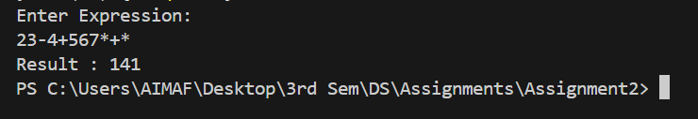

Q#4: Warehouse Inventory Stacking Simulator (Application of Stack)
A logistics company uses robotic arms to stack and unstack boxes in a warehouse. To maintain safety, no heavier box may be placed on a lighter one. When a new box arrives: • If it’s lighter than the top box → push it. • If it’s heavier → repeatedly pop boxes until a heavier or equal box is found, then push it. Display the final stack configuration from top (lightest) to bottom (heaviest). This models warehouse stacking algorithms used in robotic sorting.

CODE:
//Q#4: Warehouse Inventory Stacking Simulator (Application of Stack)
// A logistics company uses robotic arms to stack and unstack boxes in a warehouse. To maintain safety, no heavier box may be placed
// on a lighter one. When a new box arrives:
// • If it’s lighter than the top box → push it.
// • If it’s heavier → repeatedly pop boxes until a heavier or equal box is found, then push it.
// Display the final stack configuration from top (lightest) to bottom (heaviest). This models warehouse stacking algorithms used in
// robotic sorting.
#include <iostream>
#include <stack>
using namespace std;

int main()
{
stack<int> st;
int length;
int num;
cout << "How many boxes you want to enter? " << endl;
cin >> length;
for (int i = 0; i < length; i++)
{
cout << "Enter weight of box " << i + 1 << ": " << endl;
cin >> num;
if (st.empty() || st.top() > num)
{
st.push(num);
}
else
{
while (!st.empty() && st.top() < num)
{
st.pop();
}
st.push(num);
}
}
// displaying stack numbers
cout << "\nFinal stack (top to bottom): ";
while (!st.empty())
{
cout << st.top() << " ";
st.pop();
}

return 0;
}

OUTPUT:
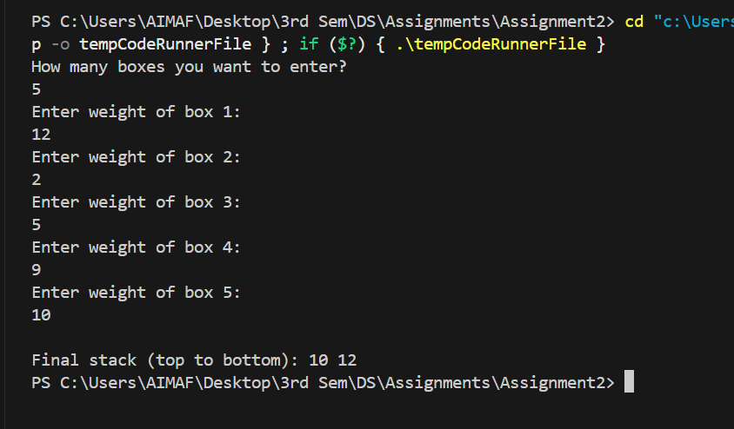

Q#5: Airport Shuttle Ticketing Queue (Static Queue Implementation)
At large airports, a shuttle service transports passengers between terminals. Passengers queue up to buy tickets following the first come, first-served rule. Design a static queue (array-based) that manages ticket sales. Each passenger record includes: • Name • Destination Terminal • Ticket Type (VIP/Regular) Operations: 1. enqueuePassenger() 2. dequeuePassenger() 3. displayQueue() 4. isFull()/isEmpty() This queue system mirrors real airport automation software used for passenger flow management.

CODE:

//Q#5: Airport Shuttle Ticketing Queue (Static Queue Implementation)
// At large airports, a shuttle service transports passengers between terminals. Passengers queue up to buy tickets following the first
// come, first-served rule.
// Design a static queue (array-based) that manages ticket sales. Each passenger record includes:
// • Name
// • Destination Terminal
// • Ticket Type (VIP/Regular)
// Operations:
// 1. enqueuePassenger()
// 2. dequeuePassenger()
// 3. displayQueue()
// 4. isFull()/isEmpty()
// This queue system mirrors real airport automation software used for passenger flow management.
#include <iostream>
using namespace std;

class Queue {
public:
static const int size = 5;
string name[size];
string destination[size];
string ticketType[size];
int front;
int rear;
public:
Queue() {
front = rear = -1;
}
bool isFull() {
return rear == size - 1;
}

bool isEmpty() {
return front == -1 || front > rear;
}
void enqueuePassenger(string name,string des,string Tt) {
if (isFull()) {
cout << "Queue Overflow\n";
return;
}
rear++;
if (front == -1)
front = 0;
this->name[rear]=name;
this->destination[rear]=des;
this->ticketType[rear]=Tt;
cout << "Data pushed\n";
}

void dequeuePassenger() {
if (isEmpty()|| front > rear ) {
cout << "No data present.\n";
return;
}
cout << "Dequeing 1st Passengers details:\n";
cout << name[front] << " " << destination[front] << " " << ticketType[front] << endl;
front++;
}

void displayQueue() {
if (front == -1) {
cout << "No Data stored.\n";
return;
}
cout << "Data is given below : " << endl;
for (int i = front; i <= rear; i++){
cout << name[i] << " " ;
cout << destination[i] << " " ;
cout << ticketType[i] << " " ;
cout << endl;
}
}

};

int main() {
Queue q;
q.enqueuePassenger("Ali", "Lahore", "VIP");
q.enqueuePassenger("Sara", "Karachi", "Economy");
q.enqueuePassenger("Aima", "Karachi", "Economy");
q.enqueuePassenger("Abdullah", "Karachi", "Economy");
q.enqueuePassenger("kiran", "Karachi", "Economy");
q.enqueuePassenger("Eman", "Karachi", "Economy");
q.displayQueue();
q.dequeuePassenger();
q.displayQueue();
q.dequeuePassenger();
q.dequeuePassenger();
q.dequeuePassenger();
q.displayQueue();
q.dequeuePassenger();
q.dequeuePassenger();
}

OUTPUT:
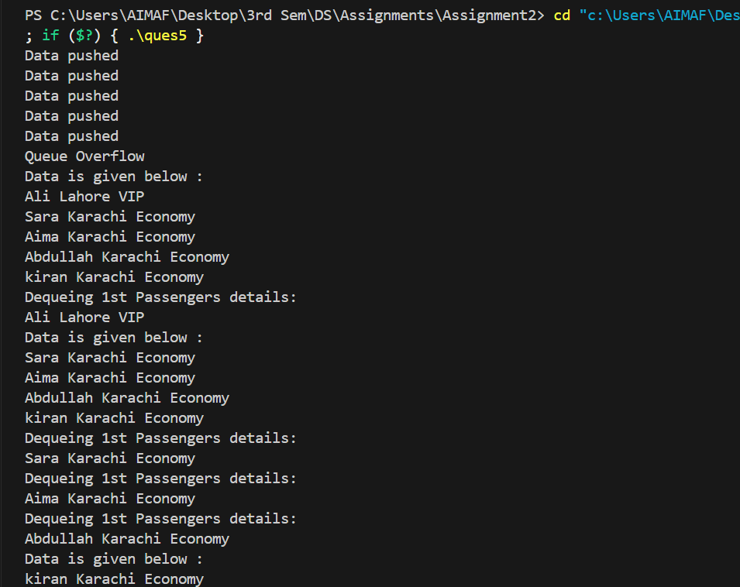

Q#6: Hospital Appointment Scheduling System (Dynamic Queue Implementation)
Hospitals often need to dynamically manage patient appointments as new cases arrive. Develop a dynamic queue (linked-list-based) for scheduling patient consultations. Each record stores: • Patient Name • Patient ID • Doctor’s Name • Appointment Time Operations: 1. addPatient() 2. callNextPatient() 3. displayAllAppointments() This simulation reflects real-time queuing logic used in hospital management systems to improve patient flow.

CODE:
// Q#6: Hospital Appointment Scheduling System (Dynamic Queue Implementation)
// Hospitals often need to dynamically manage patient appointments as new cases arrive. Develop a dynamic queue (linked-list-based)
// for scheduling patient consultations.
// Each record stores:
// • Patient Name
// • Patient ID
// • Doctor’s Name
// • Appointment Time
// Operations:
// 1. addPatient()
// 2. callNextPatient()
// 3. displayAllAppointments()
// This simulation reflects real-time queuing logic used in hospital management systems to improve patient flow.
#include <iostream>
using namespace std;

class Node
{
public:
string patientName;
int patientId;
string docName;
string time;
Node *next;

Node(string n, int id, string dn, string t)
{
patientName = n;
patientId = id;
docName = dn;
time = t;
next = nullptr;
}
};

class Queue
{
public:
Node *front;
Node *rear;
Node *next;

Queue()
{
front = rear = next = nullptr;
}

void addPatient(string n, int id, string dn, string t)
{
Node *newNode = new Node(n, id, dn, t);
if (rear == nullptr)
{
front = rear = newNode;
}
else
{
rear->next = newNode;
rear = newNode;
}

cout << "Patient added successfully.\n";
}

void callNextPatient()
{
if (front == nullptr)
{
cout << " No patients in the queue.\n";
return;
}

cout << "\n Calling next patient:\n";
cout << front->patientName << " " << front->patientId << " "
<< front->docName << " " << front->time << endl;

Node *del = front;
front = front->next;
delete del;

if (front == nullptr)
rear = nullptr;
}
void displayAllAppointments()
{
if (front == nullptr)
{
cout << "Nooo appointments available.\n";
return;
}
Node *temp = front;
cout << "Available Appointments are given below : " << endl;
while (temp != nullptr)
{
cout << temp->patientName << " " << temp->patientId << " " << temp->docName << " " << temp->time << " " << endl;
temp = temp->next;
}
}
};

int main()
{
Queue q;
q.addPatient("Ali", 101, "Dr. Ahmed", "10:00 AM");
q.addPatient("Sara", 102, "Dr. Hamid", "10:30 AM");
q.addPatient("Zain", 103, "Dr. Fatima", "11:00 AM");

cout << endl;
q.displayAllAppointments();

cout << endl;
q.callNextPatient();

cout << endl;
q.displayAllAppointments();
return 0;
}

OUTPUT:
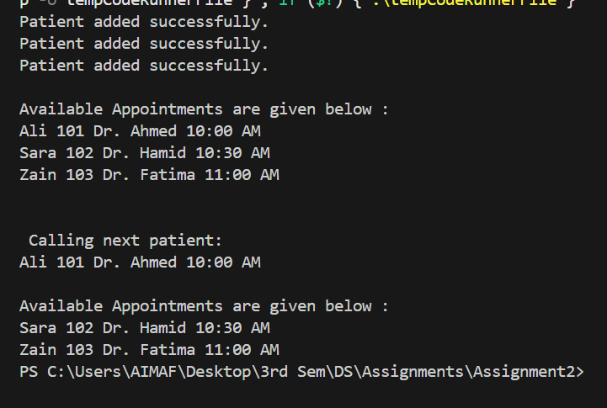

Q#7: Smart Parking Lot Management System (Circular Queue Application)
A smart parking lot with fixed slots uses a circular queue to track parked cars and efficiently reuse empty slots. Each car record includes: • Car Number • Arrival Time • Slot Number Operations: 1. parkCar() 2. removeCar() 3. displayParkingStatus() This case study represents how smart parking systems optimize limited parking spaces using circular data structures.

CODE:
// Q#7: Smart Parking Lot Management System (Circular Queue Application)
// A smart parking lot with fixed slots uses a circular queue to track parked cars and efficiently reuse empty slots.
// Each car record includes:
// • Car Number
// • Arrival Time
// • Slot Number
// Operations:
// 1. parkCar()
// 2. removeCar()
// 3. displayParkingStatus()
// This case study represents how smart parking systems optimize limited parking spaces using circular data structures.
#include <iostream>
using namespace std;
class CircularQueue
{
int *carNumber;
string *arrivalTime;
string *slotNum;
int currSize, cap;
int f;
int r;

public:
CircularQueue(int size)
{
cap = size;
carNumber = new int[cap];
arrivalTime = new string[cap];
slotNum = new string[cap];
f = 0;
r = -1;
currSize = 0;
}
void parkCar(int cn, string aT, string sN)
{
if (currSize == cap)
{
cout << "Parking is Full" << endl;
return;
}
r = (r + 1) % cap;
carNumber[r] = cn;
arrivalTime[r] = aT;
slotNum[r] = sN;
currSize++;
}
void removeCar()
{
if (empty())
{
cout << "Parking is empty." << endl;
return;
}
f = (f + 1) % cap;
currSize--;
if (currSize == 0)
{
f = 0;
r = -1;
}
}
bool empty()
{
return currSize == 0;
}

void displayParkingStatus()
{
if (empty())
{
cout << "Parking is empty." << endl;
return;
}
cout << "In parking we have : " << endl;
for (int i = 0; i < currSize; i++)
{
int index = (f + i) % cap;
cout << "Car: " << carNumber[index]
<< ", Arrival: " << arrivalTime[index]
<< ", Slot#: " << slotNum[index] << endl;
}
cout << endl;
}
};
int main()
{
CircularQueue pq(3);
pq.parkCar(101, "09:00 AM", "A1");
pq.parkCar(102, "09:15 AM", "A2");
pq.displayParkingStatus();

pq.removeCar();
pq.parkCar(103, "09:30 AM", "A3");
pq.displayParkingStatus();

pq.parkCar(104, "09:45 AM", "A4");
pq.removeCar();
pq.displayParkingStatus();

return 0;
}

OUTPUT:
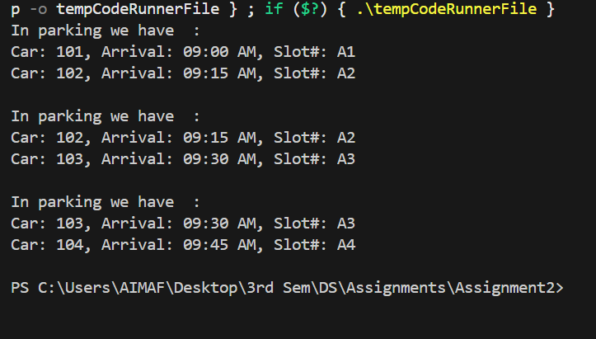

Q#8: Train Compartment Reservation System (Double-Ended Queue Application)
The national railway’s reservation system must handle both VIP and regular passengers. VIP passengers get front-end bookings, while regular passengers are queued from the rear end. Design a double-ended circular queue (deque) to manage compartment reservations. Each record includes: • Passenger Name • Category (VIP/Regular) • Seat Number Operations: 1. bookAtFront() 2. bookAtRear() 3. cancelFromFront()/cancelFromRear() 4. displayAllReservations() This models how transportation systems dynamically prioritize customers without disrupting existing orders.

CODE:
// Q#8: Train Compartment Reservation System (Double-Ended Queue Application)
// The national railway’s reservation system must handle both VIP and regular passengers. VIP passengers get front-end bookings, while
// regular passengers are queued from the rear end.
// Design a double-ended circular queue (deque) to manage compartment reservations. Each record includes:
// • Passenger Name
// • Category (VIP/Regular)
// • Seat Number
// Operations:
// 1. bookAtFront()
// 2. bookAtRear()
// 3. cancelFromFront()/cancelFromRear()
// 4. displayAllReservations()
// This models how transportation systems dynamically prioritize customers without disrupting existing orders.
#include <iostream>
using namespace std;
string name[5];
string catogory[5];
int seatNum[5];
int s = 0, n = 5;
bool empty()
{
return s == 0;
}

bool isFull()
{
return s == n;
}
void bookAtfront(string nm, string c, int sz)
{
if (isFull())
return;
if (empty())
{
name[0] = nm;
catogory[0] = c;
seatNum[0] = sz;
}
else
{
for (int i = s; i > 0; i--)
{
name[i] = name[i - 1];
catogory[i] = catogory[i - 1];
seatNum[i] = seatNum[i - 1];
}

name[0] = nm;
catogory[0] = c;
seatNum[0] = sz;
}
s++;
}
void bookAtrear(string nm, string c, int sz)
{
if (isFull())
{
cout << "No more bookings — list is full!\n";
return;
}

name[s] = nm;
catogory[s] = c;
seatNum[s] = sz;

s++;
}
void cancelFromFront()
{
if (empty())
{
cout << "Empty Already" << endl;
return;
}
for (int i = 0; i < s - 1; i++)
{
name[i] = name[i + 1];
catogory[i] = catogory[i + 1];
seatNum[i] = seatNum[i + 1];
}
s--;
cout << "First booking is cancelled!" << endl;
}
void cancelFromRear()
{
if (empty())
{
cout << "Empty Already" << endl;
return;
}
s--;
cout << "Last booking is cancelled!" << endl;
}
void displayAllReservations()
{
if (empty())
{
cout << "Empty Already" << endl;
return;
}
for (int i = 0; i < s; i++)
{
cout << name[i] << " ";
cout << catogory[i] << " ";
cout << seatNum[i] << " ";
cout << endl;
}
}

int main()
{
int choice;
string nm, c;
int sz;

do
{

cout << "1. Book at Front (VIP)\n";
cout << "2. Book at Rear (Regular)\n";
cout << "3. Cancel from Front\n";
cout << "4. Cancel from Rear\n";
cout << "5. Display All Reservations\n";
cout << "0. Exit\n";
cout << "Enter choice: ";
cin >> choice;

switch (choice)
{
case 1:
cout << "Enter Passenger Name: ";
cin >> nm;
cout << "Enter Category (VIP/Regular): ";
cin >> c;
cout << "Enter Seat Number: ";
cin >> sz;
bookAtfront(nm, c, sz);
break;

case 2:
cout << "Enter Passenger Name: ";
cin >> nm;
cout << "Enter Category (VIP/Regular): ";
cin >> c;
cout << "Enter Seat Number: ";
cin >> sz;
bookAtrear(nm, c, sz);
break;

case 3:
cancelFromFront();
break;

case 4:
cancelFromRear();
break;

case 5:
displayAllReservations();
break;

case 0:
cout << "Exiting system..." << endl;
break;

default:
cout << "Invalid option! Try again." << endl;
}
} while (choice != 0);
return 0;
}

OUTPUT:
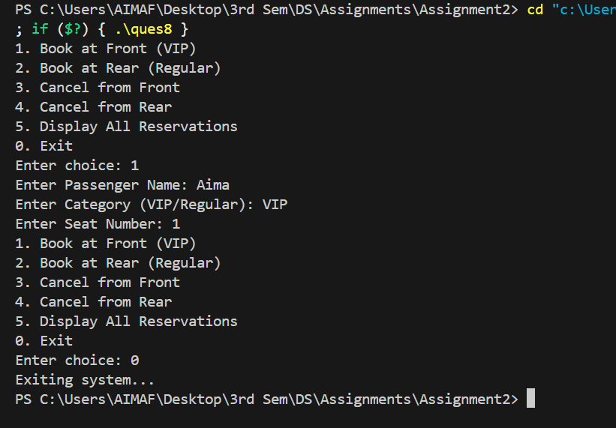

Q#9: Emergency Room Patient Management (Priority Queue Application)
In a hospital Emergency Room (ER), patients are triaged based on urgency levels (1=Critical, 4=Low). Implement a priority queue that maintains patients according to priority. Each record includes: • Patient ID • Name • Condition Description • Priority Level Simulate arrivals in order 4,1,3,2 and ensure they are treated in the order 1→2→3→4. This demonstrates how hospital triage systems manage patient queues for optimal treatment sequencing.

CODE:
// Q#9: Emergency Room Patient Management (Priority Queue Application)
// In a hospital Emergency Room (ER), patients are triaged based on urgency levels (1=Critical, 4=Low). Implement a priority queue
// that maintains patients according to priority.
// Each record includes:
// • Patient ID
// • Name
// • Condition Description
// • Priority Level
// Simulate arrivals in order 4,1,3,2 and ensure they are treated in the order 1→2→3→4. This demonstrates how hospital triage systems
// manage patient queues for optimal treatment sequencing.

// min priority queue
#include <iostream>
using namespace std;
int id[4], priority[4];
string name[4], description[4];
int s = 0, n = 4;

bool empty()
{
return s == 0;
}

bool isFull()
{
return s == n;
}

void insert(int iD, string n, string d, int p)
{
if (isFull())
{
cout << "Queue is Full" << endl;
return;
}
int i = s - 1;
while (i >= 0 && priority[i] > p)
{
id[i + 1] = id[i];
name[i + 1] = name[i];
description[i + 1] = description[i];
priority[i + 1] = priority[i];
i--;
}
id[i + 1] = iD;
name[i + 1] = n;
description[i + 1] = d;
priority[i + 1] = p;

s++;
}

void deleteVal()
{
if (empty())
{
cout << "Queue is empty" << endl;
return;
}
cout << "Critical patient " << id[0] << " " << name[0] << " " << description[0] << " " << " is now attended." << endl;
for (int i = 0; i < n; i++)
{
id[i] = id[i + 1];
name[i] = name[i + 1];
description[i] = description[i + 1];
priority[i] = priority[i + 1];
}
s--;
}

void peek()
{
if (empty())
return;
cout << "Critical patient is " << id[0] << " " << name[0] << " " << description[0] << " " << "." << endl;
}

void display()
{
for (int i = 0; i < n; i++)
{
cout << id[i] << " ";
cout << name[i] << " ";
cout << description[i] << " ";
cout << priority[i] << " ";
cout << endl;
}

}

int main()
{
// insert value of id name description and priority respectively in min priority queue 4,1,2,3
insert(41, "Aima", "Kidding", 4);
insert(42, "Amna", "oho", 1);
insert(43, "Eman", "ops", 2);
insert(44, "Asma", "yaar", 3);
display();
deleteVal();
display();
peek();
return 0;
}

OUTPUT:
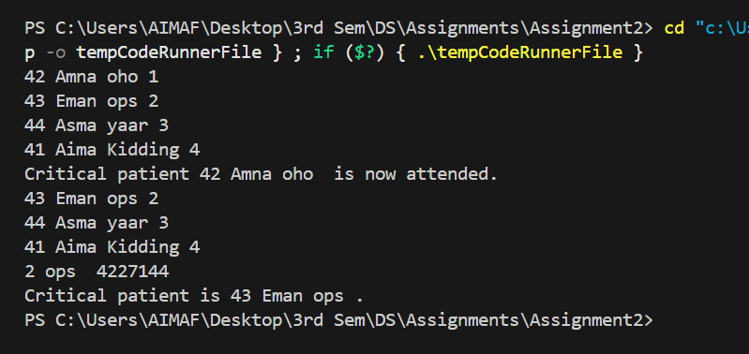

Q#10: Food Delivery Dispatch System (Application of Queue)
A food delivery service (like Foodpanda) must assign orders to riders in real time. Each order includes: • Order ID • Restaurant Name • Customer Address • Item List • Preparation Time • Order Time Operations: 1. addOrder() – Insert at front if quick items only, else at rear. 2. dispatchOrder() 3. viewNextOrder() 4. displayAllOrders() 5. cancelOrder(orderID) This models the dispatch logic of real delivery systems, balancing quick orders and high-priority deliveries using queue operations.

CODE:
// Q#10: Food Delivery Dispatch System (Application of Queue)
// A food delivery service (like Foodpanda) must assign orders to riders in real time. Each order includes:
// • Order ID
// • Restaurant Name
// • Customer Address
// • Item List
// • Preparation Time
// • Order Time
// Operations:
// 1. addOrder() – Insert at front if quick items only, else at rear.
// 2. dispatchOrder()
// 3. viewNextOrder()
// 4. displayAllOrders()
// 5. cancelOrder(orderID)
// This models the dispatch logic of real delivery systems, balancing quick orders and high-priority deliveries using queue operations.

#include <iostream>
using namespace std;

class Node
{
public:
int id;
string name;
string address;
string itemList;
string prepTime;
string orderTime;
Node *next;
Node *prev;

Node(int id, string name, string address, string itemList, string prepTime, string orderTime)
{
this->id = id;
this->name = name;
this->address = address;
this->itemList = itemList;
this->prepTime = prepTime;
this->orderTime = orderTime;
next = nullptr;
prev = nullptr;
}
};

class DoubleEndedQueue
{

public:
Node *head;
Node *tail;

DoubleEndedQueue()
{
head = tail = nullptr;
}
// insert at head if quick otherwise at tail
void addOrder(int id, string name, string address, string itemList, string prepTime, string orderTime, string type)
{
Node *newNode = new Node(id, name, address, itemList, prepTime, orderTime);
if (head == nullptr)
{
head = tail = newNode;
}
else if (type == "quick" || type == "Quick")
{
newNode->next = head;
head->prev = newNode;
head = newNode;
}
else
{
tail->next = newNode;
newNode->prev = tail;
tail = newNode;
}
}
// deletion at head
void dispatchOrder()
{
if (head == nullptr)
{
cout << "Empty" << endl;
return;
}
Node *del = head;

//Only one node
if (head == tail)
{
head = tail = nullptr;
}
//More than one node
else
{
head = head->next;
head->prev = nullptr;
}

cout << "Dispatched Order ID: " << del->id << endl;
delete del;
}
void viewNextOrder() {
if (head == nullptr) {
cout << "No orders in queue.\n";
return;
}
cout << "Next order to dispatch:\n";
cout << "ID: " << head->id
<< ", Restaurant: " << head->name
<< ", Address: " << head->address
<< ", Items: " << head->itemList
<< ", Prep Time: " << head->prepTime
<< ", Order Time: " << head->orderTime
<< endl;
}

void displayAllOrders()
{
if (head == nullptr) {
cout << "No orders to display.\n";
return;
}

cout << "\nAll Active Orders\n";
Node* temp = head;
while (temp != nullptr) {
cout << "Order ID: " << temp->id << endl;
cout << "Restaurant: " << temp->name << endl;
cout << "Address: " << temp->address << endl;
cout << "Items: " << temp->itemList << endl;
cout << "Preparation Time: " << temp->prepTime << endl;
cout << "Order Time: " << temp->orderTime << endl;
temp = temp->next;
}
}

void cancelOrder(int orderID)
{
if (head == nullptr) {
cout << "No orders to cancel.\n";
return;
}

Node* temp = head;

// 🔹 Case 1: Order at head
if (temp->id == orderID) {
head = head->next;
if (head != nullptr)
head->prev = nullptr;
else
tail = nullptr; // list became empty
delete temp;
cout << "Order ID " << orderID << " cancelled (was at front).\n";
return;
}

// 🔹 Traverse to find order
while (temp != nullptr && temp->id != orderID)
temp = temp->next;

// 🔹 Case 2: Not found
if (temp == nullptr) {
cout << "Order ID " << orderID << " not found.\n";
return;
}

// 🔹 Case 3: Found at tail
if (temp == tail) {
tail = tail->prev;
tail->next = nullptr;
delete temp;
cout << "Order ID " << orderID << " cancelled (was at rear).\n";
return;
}

// 🔹 Case 4: Found in middle
temp->prev->next = temp->next;
temp->next->prev = temp->prev;
delete temp;
cout << "Order ID " << orderID << " cancelled (was in middle).\n";
}

};

int main()
{
DoubleEndedQueue dq;
int choice;

do {
cout << "\nFood Delivery Dispatch System\n";
cout << "1. Add Order\n";
cout << "2. Dispatch Order\n";
cout << "3. View Next Order\n";
cout << "4. Display All Orders\n";
cout << "5. Cancel Order\n";
cout << "0. Exit\n";
cout << "Enter your choice: ";
cin >> choice;
cin.ignore(); // to clear newline after integer input

if (choice == 1) {
int id;
string name, address, itemList, prepTime, orderTime, type;

cout << "\nEnter Order ID: ";
cin >> id;
cin.ignore();
cout << "Enter Restaurant Name: ";
getline(cin, name);
cout << "Enter Customer Address: ";
getline(cin, address);
cout << "Enter Item List: ";
getline(cin, itemList);
cout << "Enter Preparation Time: ";
getline(cin, prepTime);
cout << "Enter Order Time: ";
getline(cin, orderTime);
cout << "Enter Type (quick / regular): ";
cin >> type;

dq.addOrder(id, name, address, itemList, prepTime, orderTime, type);
cout << "Order Added Successfully!\n";
}

else if (choice == 2) {
dq.dispatchOrder();
}

else if (choice == 3) {
dq.viewNextOrder();
}

else if (choice == 4) {
dq.displayAllOrders();
}

else if (choice == 5) {
int id;
cout << "Enter Order ID to cancel: ";
cin >> id;
dq.cancelOrder(id);
}

else if (choice == 0) {
cout << "Exiting system...\n";
}

else {
cout << "Invalid choice. Try again.\n";
}

} while (choice != 0);
return 0;
}

OUTPUT:
